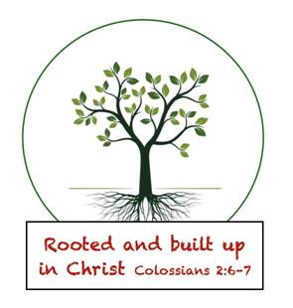
November 25, 2019
Greetings Senior Kindergarten Parents and Friends,
I hope everyone had a great Thanksgiving and got a chance to relax and spend time with family and friends.
Quote of the Week: All SK Students: Ms. Johnson how old are you? Me: Old enough to be a teacher (smile).
Highlights of our Week:
Reading: Because of our short week, we will focus on reading activities that have a Thanksgiving theme. This will include ABC order activities and Turkey sentence scrambles.
Math: We will continue to work in topic 6, learning how to use the (+) sign.
Social Studies: This week we will learn how Pilgrim children and Wampanoag children worked and played.
Religion: This week we discuss Thankfulness and the blessings we have.
Other Items:
- Folders will come home on Monday this week. Please return them Tuesday so I can work on them over the Thanksgiving break.
- The 2nd and final holiday book order will be 12/5.
- The feast will be on Tuesday 11/26, we have a huge menu that we all voted on and everyone brings something. Mrs. Brayton and I are supplying the main dishes (ham, cornbread, corn on the cob, popcorn and mash potatoes). Please see the list below for what your child should bring.
Brynn, Caleb, Fletcher, Amanuel- 1 large bag of grapes
Zeus, Grace- 1 Large bag of baby carrots and 1 bottle of ranch dressing
Henry, Austin, Adam- 1 large container of strawberries (washed)
James, Bella, Adrinna-1 bag of oranges cut into quarters
Arianna, Torsten, Mariel- 1 bag of apples cut into quarters
Ellie-Dessert
Elliott, Charlotte-4 large red or yellow bell peppers cut into strips
Ares, Owen- 2 bags of broccoli florets

In Him Who Loves Us All
Jackie Johnson-Lindmark

Important Dates:
11/26- Senior Kindergarten Thanksgiving Feast
11/27-11/29- Thanksgiving Break (No School)

