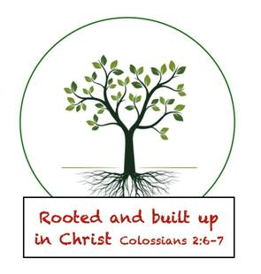

February 24, 2020,
Greetings Senior Kindergarten Parents and Friends,
I hope everyone had a great weekend.
Quote of the Week James: Ms. Johnson are you okay? Your voice sounds funny.”
Reading: This week we are working on week 2 in unit 6. We will focus on the /k/ sound this week, we will also learn when to use /c or k/ when spelling words and using /ck/ at the end of words.
Math: This week we will finish up Topic 8, we will review the unit and have our topic 1-8 review next week.
Religion: This week we will read the story of how Jesus walked on water and convinced his disciples that he was the living son of God.
Social Studies: Our inventor this week is Valerie Thomas who invented an illusion transmitter that can make objects appear in 3-D using concave mirrors. We will end Black history month with a lesson on why we celebrate it, and a video on African American inventors.
Science: February is also National Dental Health Month, so Dr. Rabbit and the Tooth Defenders will be helping us learn about good dental hygiene. Each student will receive a gift from Dr. Rabbit that includes a toothbrush, paste and fun facts about dental hygiene. Look for it in Tuesday Folders.

Other Items:
- Over the last few weeks, our free play has become a bit rougher than usual. Although I understand that in most cases the play is innocent, it has gotten to the point that I am going to be telling the kids that we have to stop physical contact games (freeze tag, cats, and anything that involves touch). I want them to play and grow together but we need to work on being mindful of others. Please reiterate to your child at home the importance of respecting the self-space of others. If you have any questions or concerns, please let me know and thanks for all your support.
- This Wednesday is Ash Wednesday. It is the beginning of the Lenten season and we will be learning a lot about the teachings of Jesus and the miracles he performed before his death. Pastor Lyle will be giving the Senior Kindergarten students ashes and blessings on Wednesday. I will be talking to the students about why we do this before Wednesday. If you don’t want your student to receive ashes, please let me know ASAP and your child will only get the blessing.
- As you know this year, Ms. Holm and I started a pilot program for Kindergarten coding. This opportunity provides young learners a chance to start understanding the language and structure of early coding techniques. Ms. Holm has created an outstanding program that the students are loving and learning so much about. In Tuesday folders this week, you will find the link used for our coding activities and some information about the things we are doing. Please feel free to look at the lessons we have worked on so far and let you student continue to practice on them. I would love to see us continue the program with the kids. Please check it out and let Mr. Koehne know your thoughts.

Important Dates:
02/25- Scholastic Book Order Due
02/26- Ash Wednesday
02/28- Hot Lunch & School Spirit Day

Have a Great Week
In Him Who Loves Us All
Jackie Johnson-Lindmark

