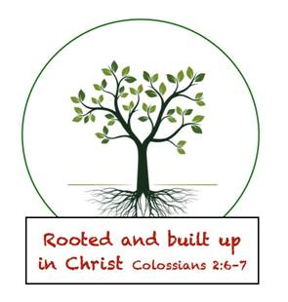

January 20, 2020,
Greetings Senior Kindergarten Parents and Friends,
I hope everyone had a safe and warm weekend and enjoyed the extra day off.
Reading: This week we begin unit 5, our letter of the week will be /H h/ and our word of the week is /my/. This week I will also be working on capitalization and punctuation with some students and letter sound connections with others.
Math: This week we will continue our work in topic 7 (Understanding Subtraction). Our lessons this week include using the minus (-) sign and representing and explaining subtraction with equations.
Science: This week we are learning about penguins. We will learn about the environments, habits and sizes and other interesting facts about these cute little animals.
Social Studies: This week we are learning about rights and responsibilities.
Religion: This week we will continue to work on learning the meanings of each petition of the Lord’s Prayer. This week we are working on “And lead us not into temptation but deliver us from evil”.
Other Items:
- Although the weather has been mild the last few weeks, it is winter and flu season. We will be going outside daily for recess and we need to be prepared for sudden changes. Please make sure your child has a hat, gloves, and any other weather appropriate outer wear, daily. It is also a good time to ensure that your child has a full change of winter clothes at school, including socks and underwear.

Important Dates:
01/24-Scholastic Book Order Due
01/24-Hot Lunch & School Spirit Day

Have a Great Week
In Him Who Loves Us All
Jackie Johnson-Lindmark

